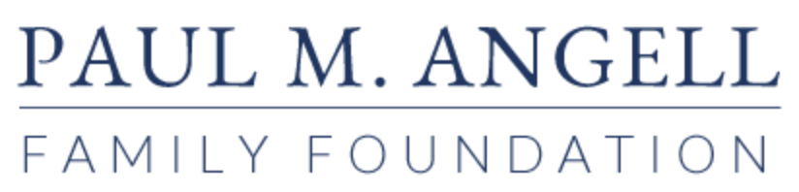

PRESS RELEASE
For Immediate Release
Contact: Jay Kelly PR
jaykellypr@gmail.com, 312.315.3935
CHICAGO’S LATINO NONPROFIT ARTS LEADERS MET WITH INFLUENTIAL FOUNDATIONS FOR FRANK CONVERSATIONS ABOUT FUNDING EQUITY AT FIRST-EVER CHICAGO LATINO ARTS AND CULTURE SUMMIT

Quienes Somos - ¡Aquí Estamos! (Who We Are - We Are Here!), sponsored by the Paul M. Angell Family Foundation, brought Latino nonprofits together with foundations to open paths for Latinos to pursue a more equitable share of philanthropic dollars
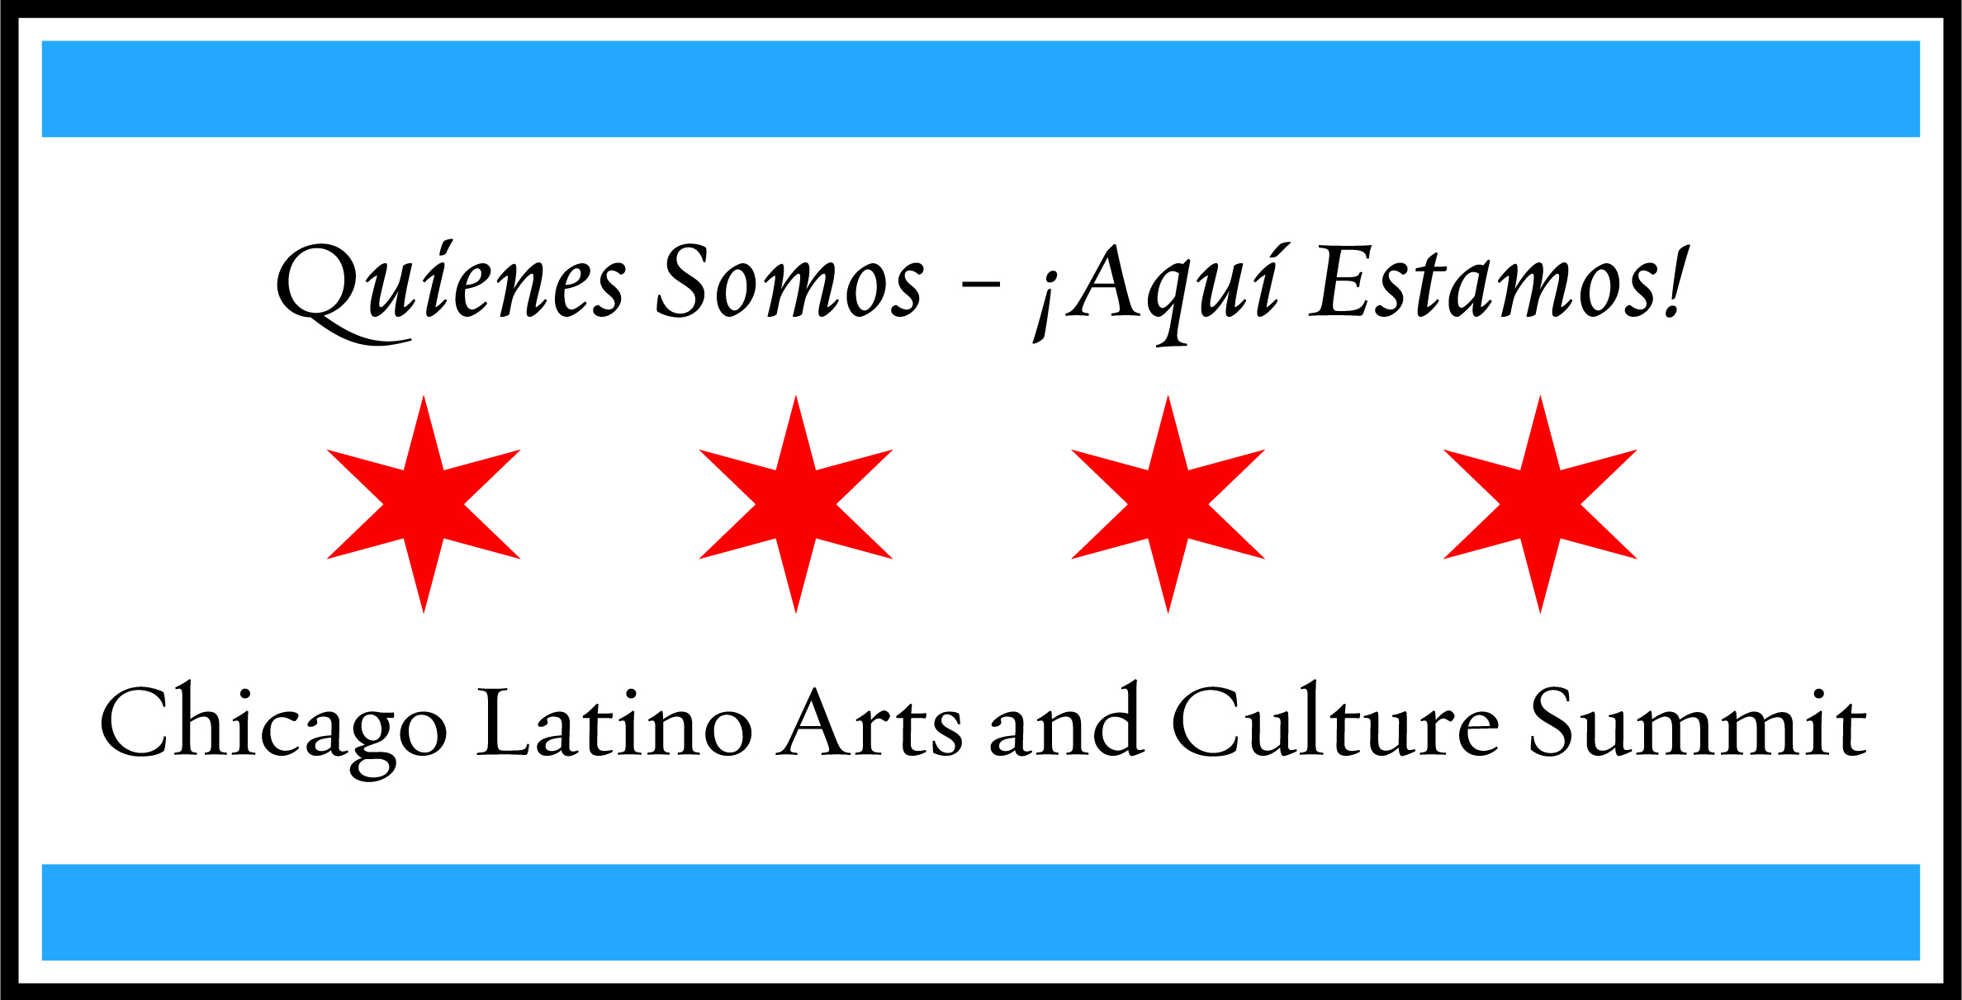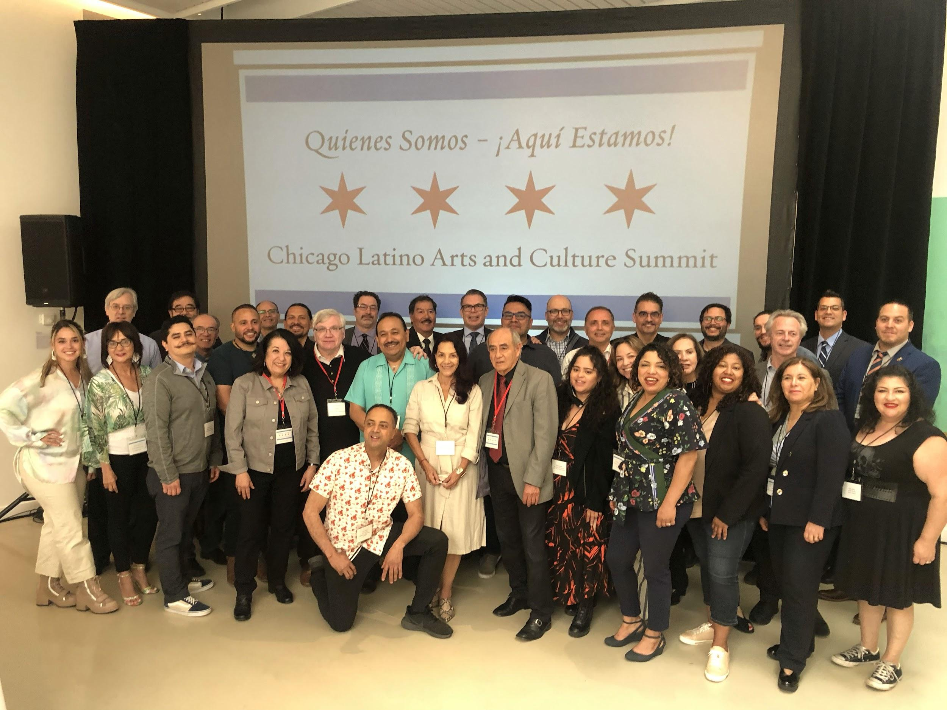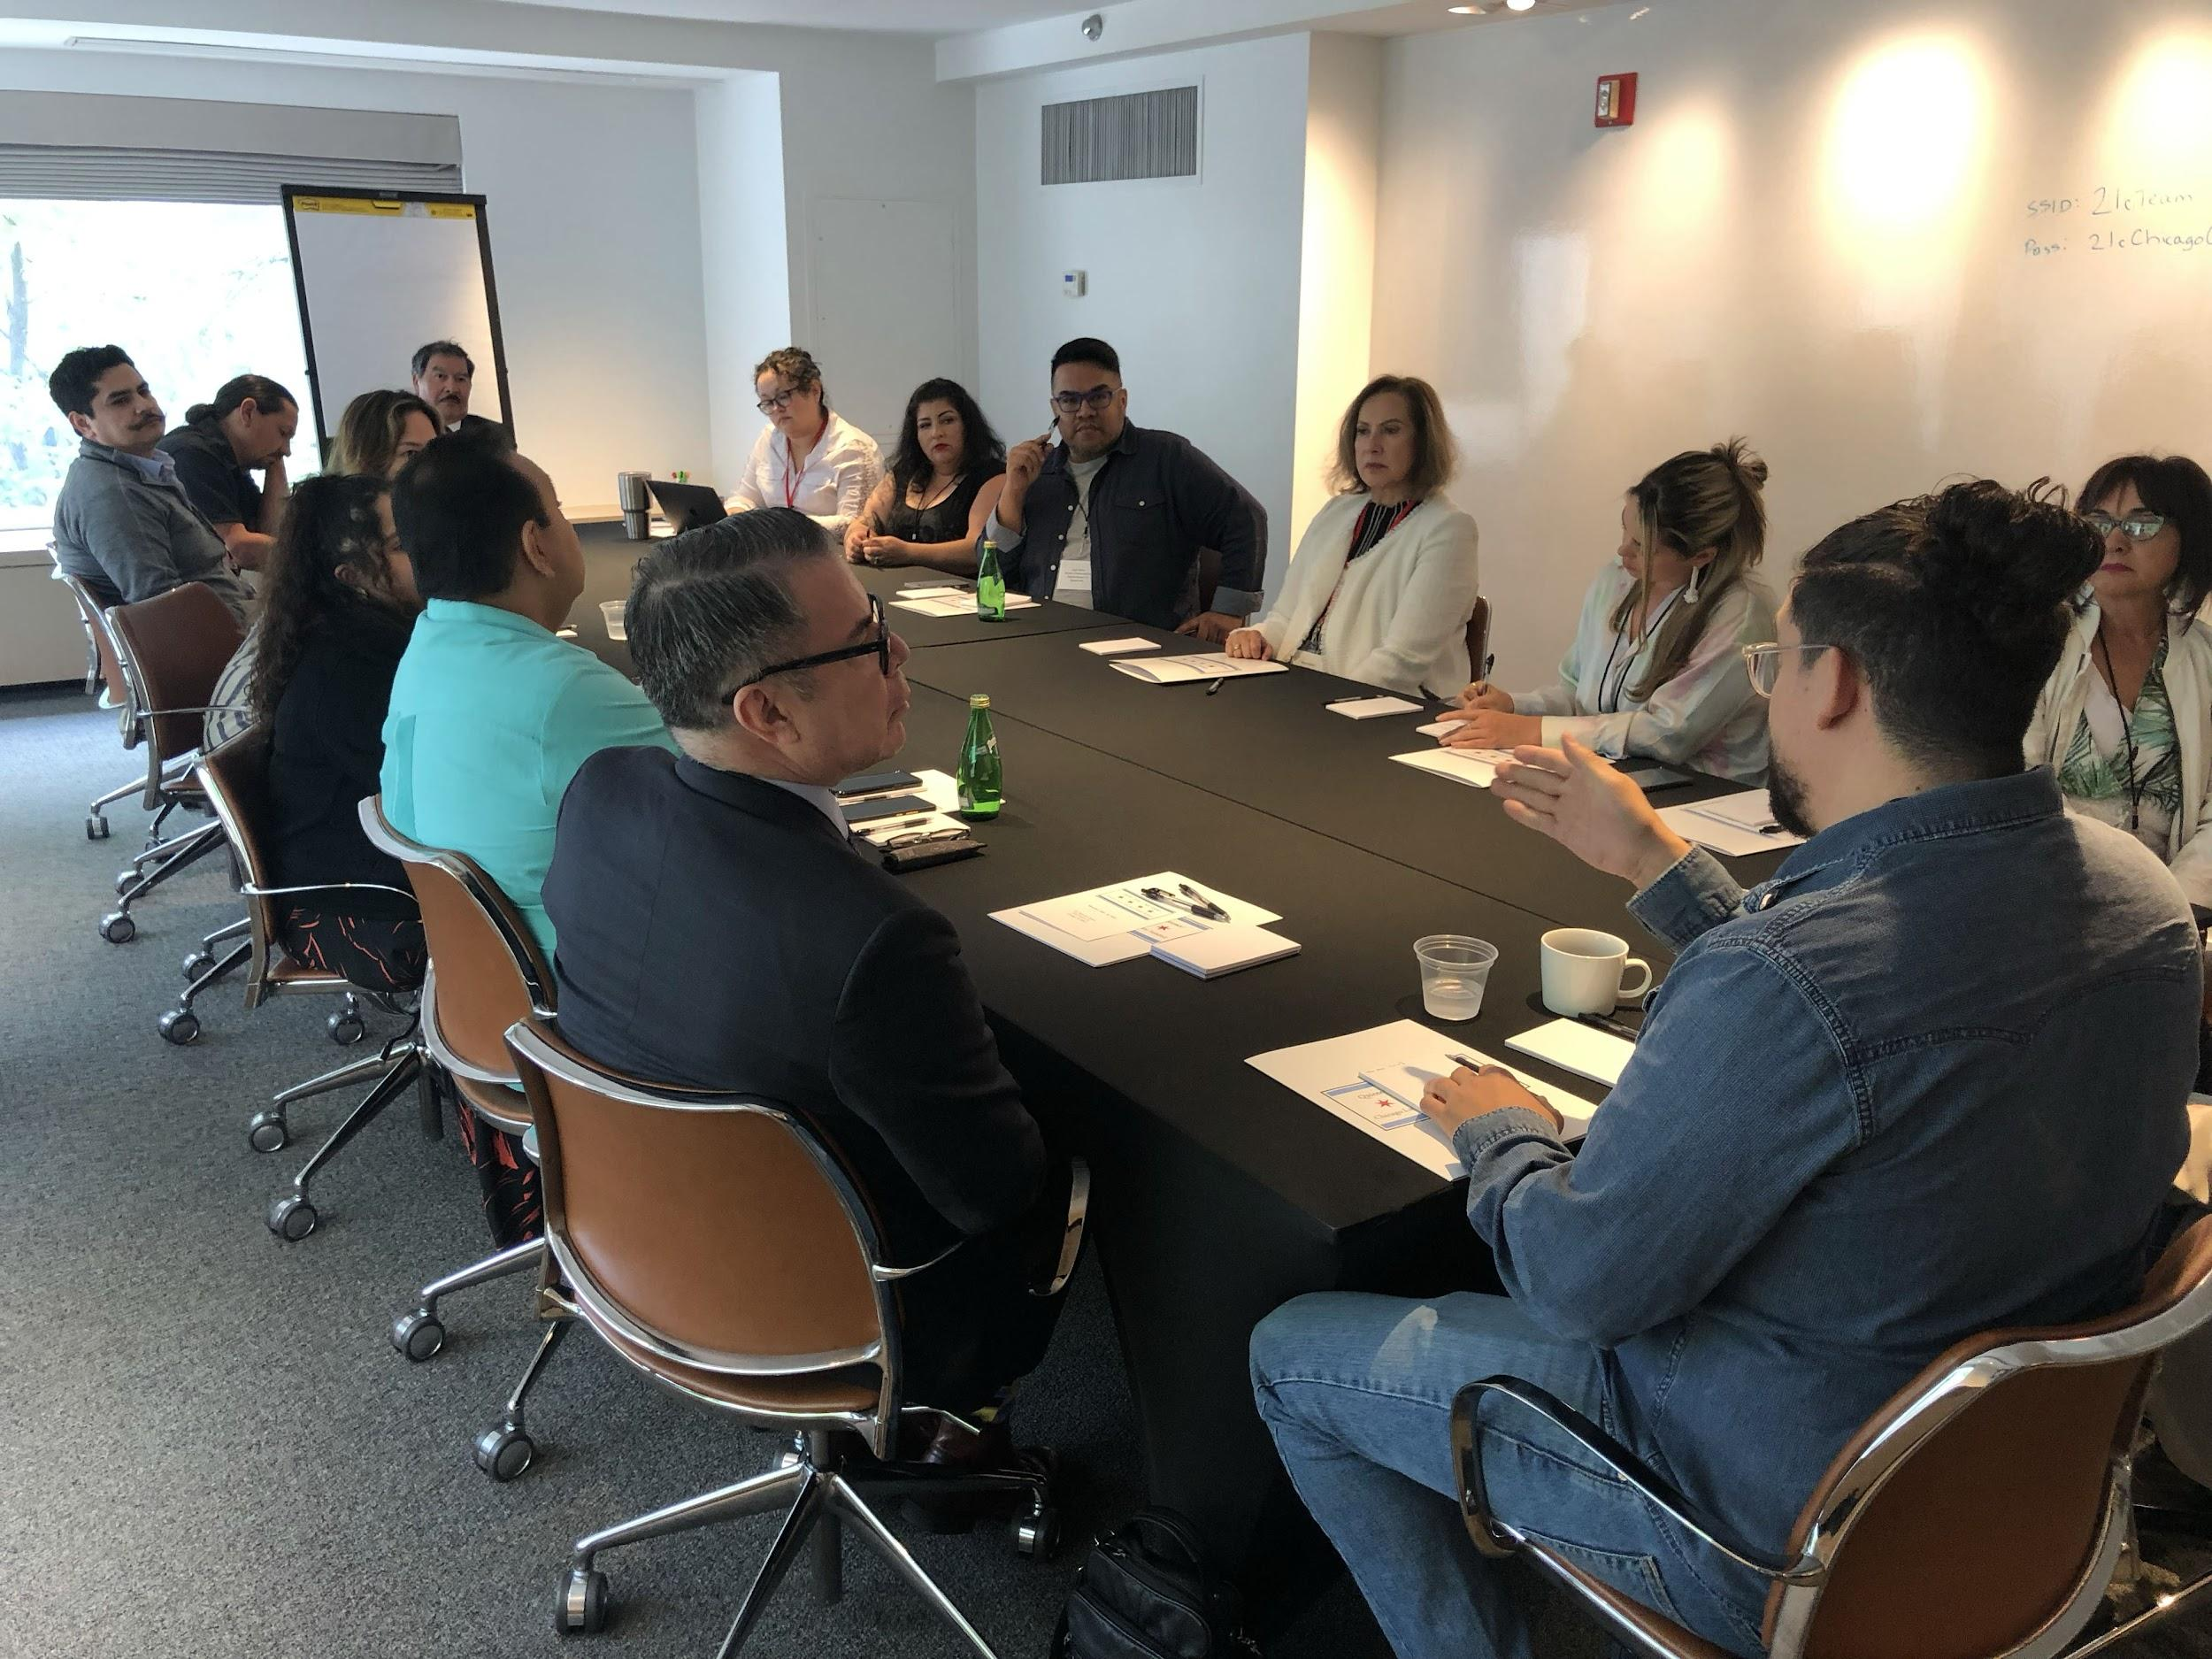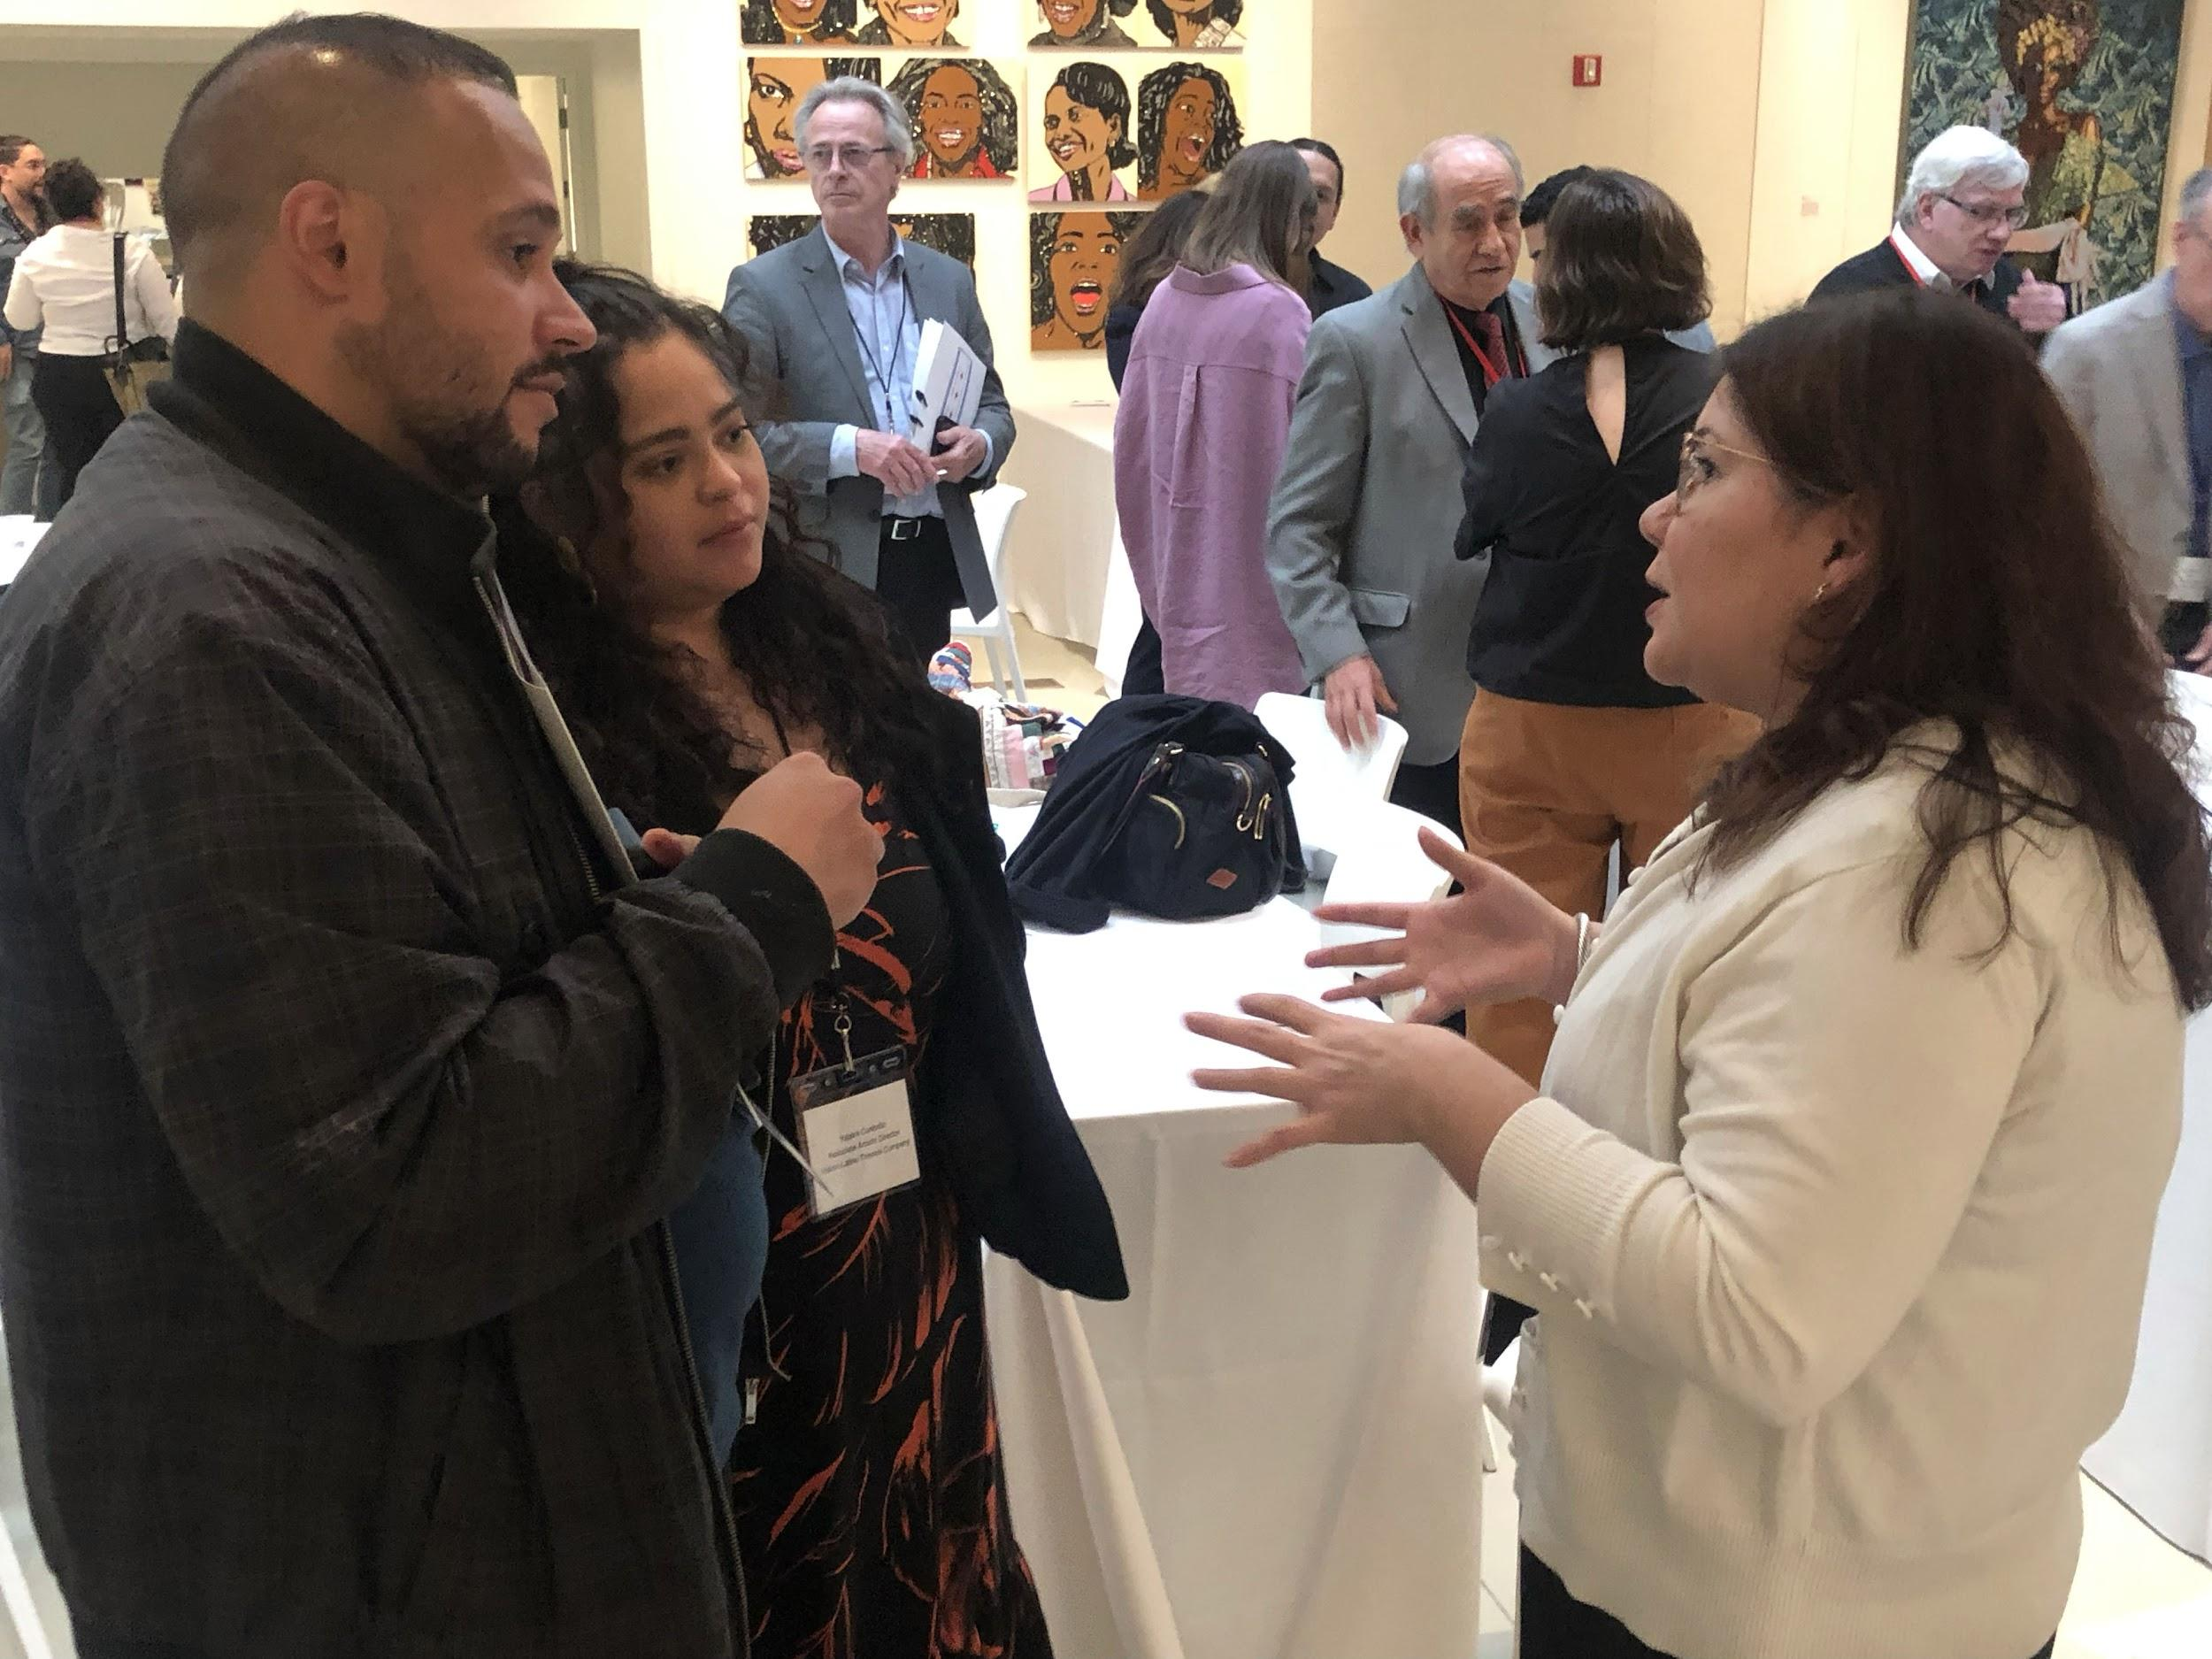
CHICAGO, May 24, 2022 - “One-third of Chicago is Latino. Does your funding portfolio reflect that? If not, why not?”

That was one of many pointed questions that sparked frank dialogue between leaders of Chicago’s Latino nonprofit arts groups and their counterparts at some of the city’s most influential foundations at Quienes Somos - ¡Aquí Estamos! (Who We Are - We Are Here!), the Chicago Latino Arts and Culture Summit, held Monday, May 16 at 21c Museum Hotel Chicago.
Leaders of 22 local Latino arts organizations gathered for a full morning of keynotes, panels and breakout sessions. In the afternoon, top decision-makers from some of the city’s most influential foundations arrived for an in-person meeting with their newly emboldened Latino arts leader counterparts around one key topic – boosting equity in arts funding.

“One goal is for Latino groups, representing many different identities and art forms, to come together and speak as one voice in order to get the support and recognition you deserve,” said event sponsor Michael Angell, Co-Founder and Director, Paul M. Angell Family Foundation, to set the tone for a full day of conversation, community building and action. The Angell Foundation conceived and sponsored Monday’s first-ever Chicago Arts and Culture Summit with the Chicago Latino Theater Alliance, the International Latino Cultural Center of Chicago, the National Museum of Mexican Art and the Puerto Rican Arts Alliance.

In his opening remarks, Carlos Hernández Falcón, Executive Director and Founder, Puerto Rican Arts Alliance, admitted “I used to shy away from feel-good conferences. But my hope today is that we can find new ways to act upon the growing numbers and many contributions of Chicago’s Latino community. Before, we were portrayed as a marginalized community. That is no longer true. We need to change the narrative. We all deserve to be in a better place to strengthen our organizations financially.”

Carlos Tortolero, President and Founder, National Museum of Mexican Art, agreed. “We’ve heard ‘this is the time for Latinos’ so many times, and then the money goes to the white organizations. If we continue to let this happen, it’s our fault now. We are not a minority anymore. We have to stop being afraid, because we’re not getting our fair share. We need to demand our share of power and resources.”

Breakout sessions revolved around topics including Racism and the Latino Community, moderated by Tortolero, Fundraising and Technical Support, moderated by Hernandez, and Advocacy and Media Presence, moderated by Myrna Salazar, Executive Director, the Chicago Latino Theater Alliance.
“Our group agreed Latino arts organizations have always had to work hard to control our narratives,” reported Salazar, “but we’d like to find new ways to elevate our art and make sure we are being represented in the media. The large media outlets in Chicago, specifically Spanish-language, neither has an arts or entertainment reporter any longer. That’s a problem. That’s a problem that needs to be addressed.”

Wendy Mateo, Co-Artistic Director, Teatro Vista, was met with a chorus of snapping fingers when she noted, “We have to work double to get a fraction of what white institutions have. And we often partner with white institutions so everyone can see the quality of our work. But what happens when we partner? The larger institutions mine us for new audiences. They don’t give us an equitable portion of the box office. They apply for our grants. They think we get the credit and that is enough. Funders, please stop redirecting funds to Latino artists through white institutions.”
The afternoon plenary, including funders, started with The Growing Latino Population in Chicago, with new data shared by Dr. Teresa Córdova, conference moderator and Director
of the Great Cities Institute at the University of Illinois-Chicago.
Funders also were shown a short video (watch here) demonstrating the depth, diversity and key contributions of all of Chicago’s participating Latino arts organizations, followed by a recap of key takeaways and next steps from the morning sessions.
The day concluded with a networking session to facilitate personal introductions and conversations with funding professionals from Paul M. Angell Family Foundation, John D. and Catherine T. MacArthur Foundation, Joyce Foundation, Pritzker Traubert Foundation, Terra Foundation for American Art, Driehaus Foundation and Walder Foundation.

By the end of the session, Michael Angell of the Angell Foundation revealed new plans to build on this first Chicago Latino Arts and Culture Summit and explore creating a new, ongoing advocacy organization, the Chicago Latino Arts and Culture Network.
Initial concepts for the group would be to advocate on a continual and communal basis for more equitable funding of Chicago’s Latino arts organizations, along with media advocacy, assistance with grant applications, marketing support, anti-racism initiatives, even succession planning.
“After my experience of 40 years of culture wars, I look forward to seeing a future agenda set that creates tremendous opportunities for cultural dialogues and engagement,” concluded Pepe Vargas, Founder and Executive Director of the International Latino Cultural Center of Chicago. “We are committed to working together, each of us with our distinct identities, but Latinos all, with one voice for a culturally rich Chicago.”

The full list of participating nonprofit arts organizations includes Africaribe, Aguijón Theater Company, Chicago Latino Theater Alliance, Chicago Mariachi Project, Chicago Samba, Cuerdas Clásicas, International Latino Cultural Center of Chicago, Mariachi Herencia de México, National Museum of Mexican Art, OPEN Center for the Arts, Puerto Rican Arts Alliance, Repertorio Latino Theater Company, Sones de Mexico Ensemble, Tango 21 Dance Theater, Teatro Tariakuri, Teatro Vista, The Mexican Folkloric Dance Company of Chicago, The Miracle Center, The National Museum of Puerto Rican Arts and Culture, UrbanTheater Company, Visión Latino Theatre Company and Water People Theater.
About the Paul M. Angell Family Foundation
The Paul M. Angell Family Foundation was formed to honor Paul M. Angell, founder of Newly Weds Foods in Chicago’s Hermosa community. Founded in 2011 and based in Chicago, it makes grants in three priority areas: Conservation, Performing Arts and Social Causes. For more information, visit pmangellfamfound.org.

# # #

